**Sharing Model Builders**

1. Open your project where you have saved your model builder
2. Go to View in the ArcGIS Pro select Catalog Pane:
3. Locate Toolbox in Catalog Pane:

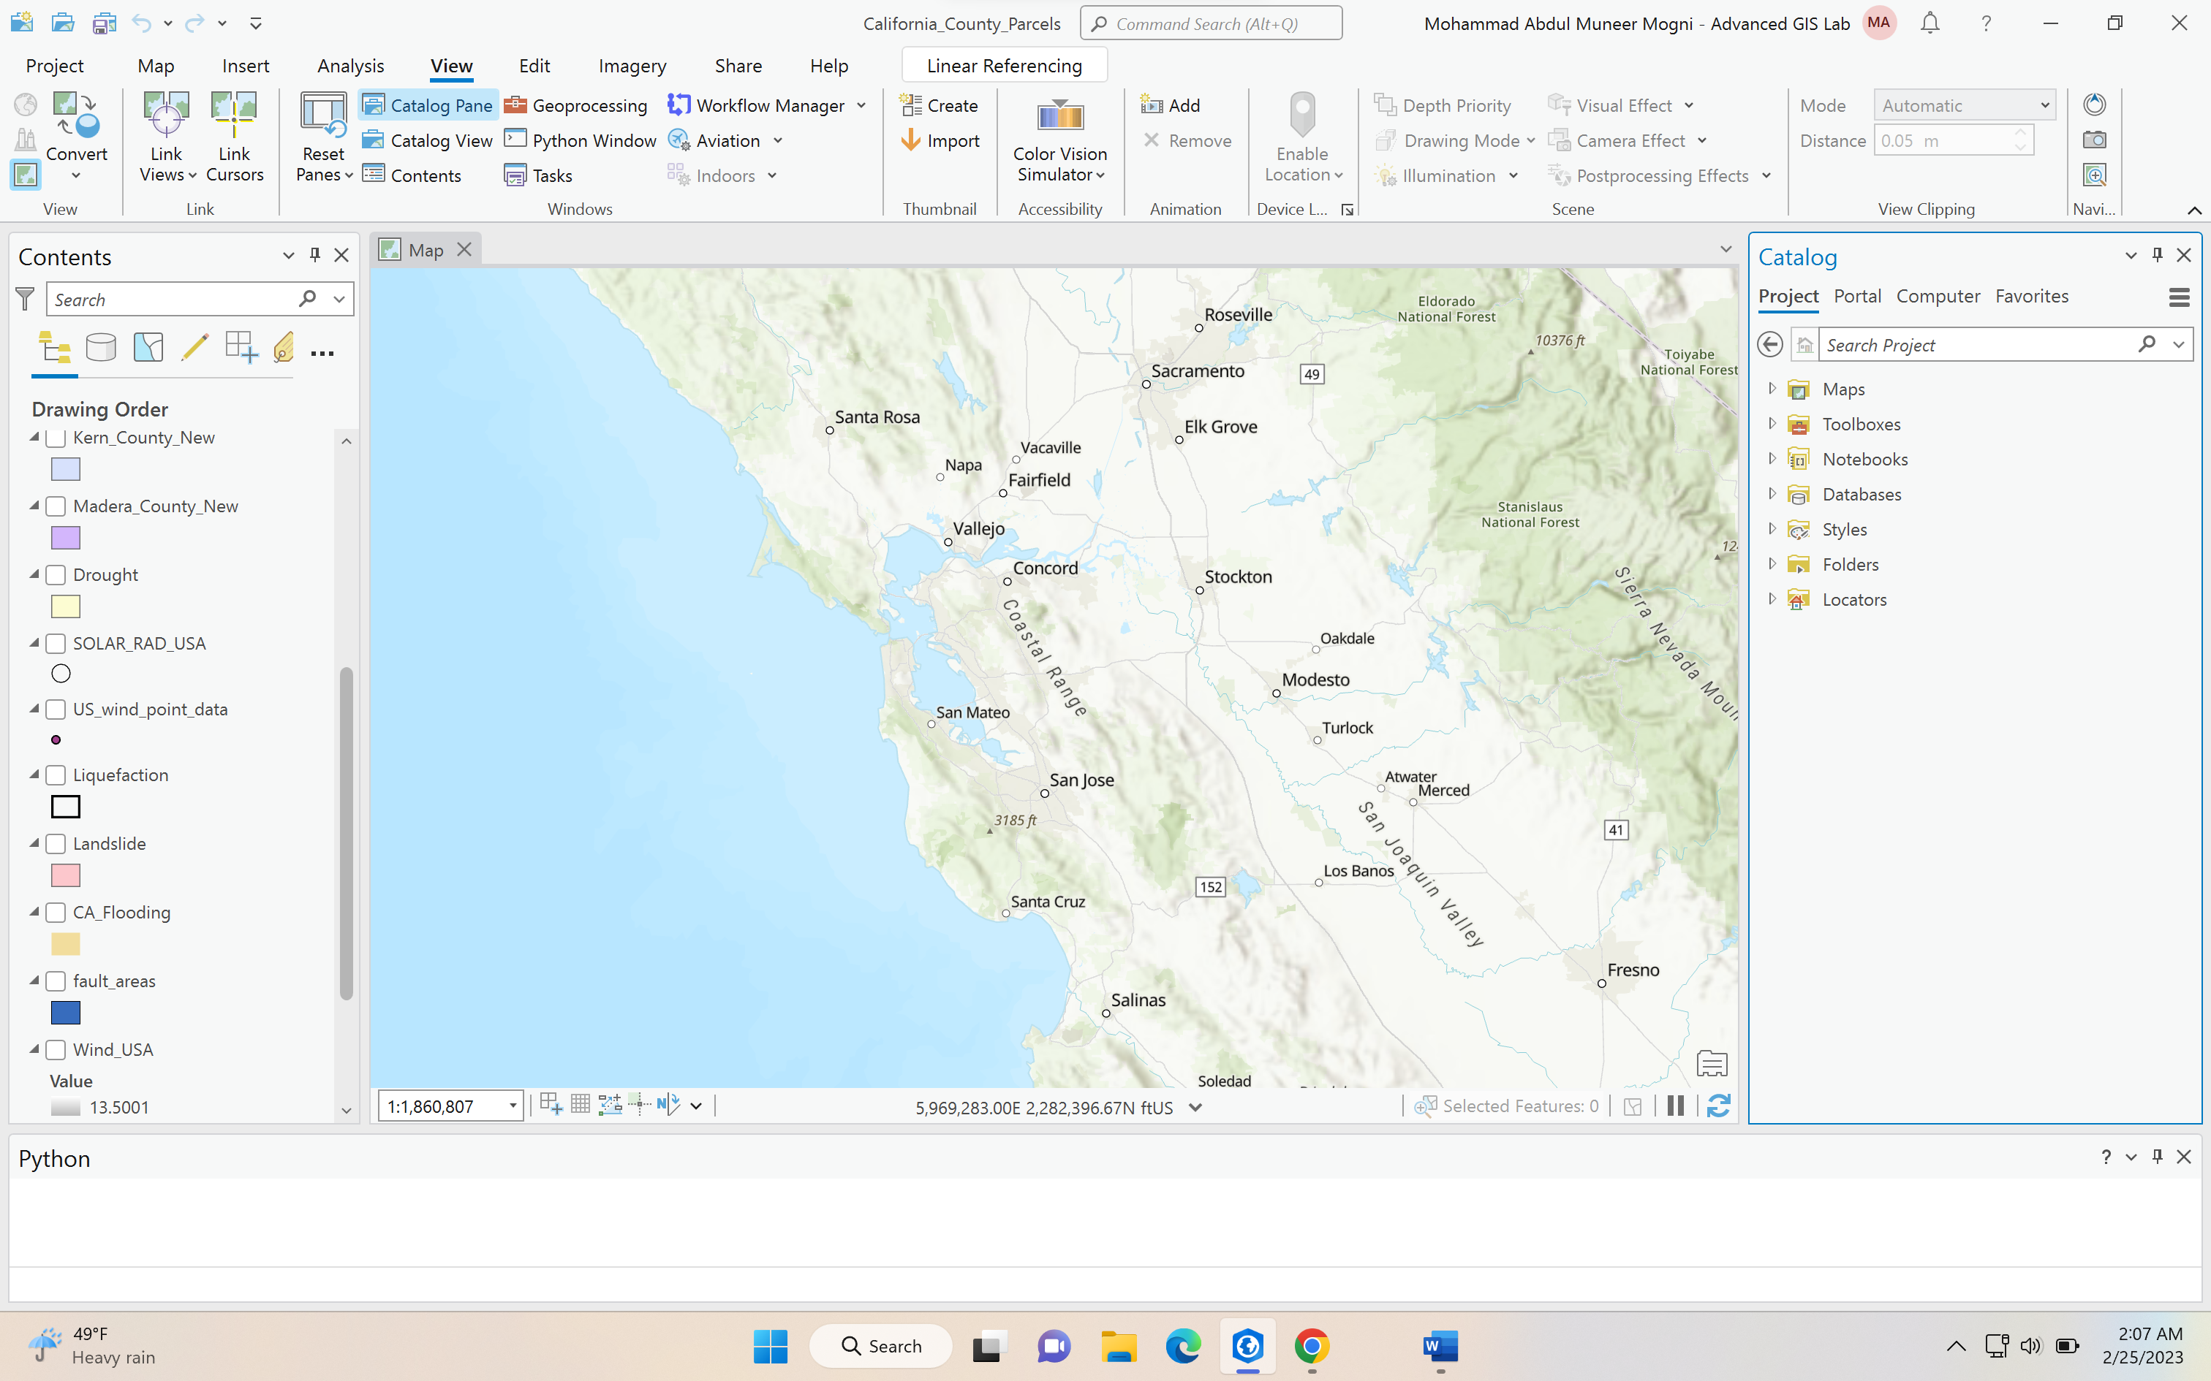

1. Open Toolboxes in Catalog Pane

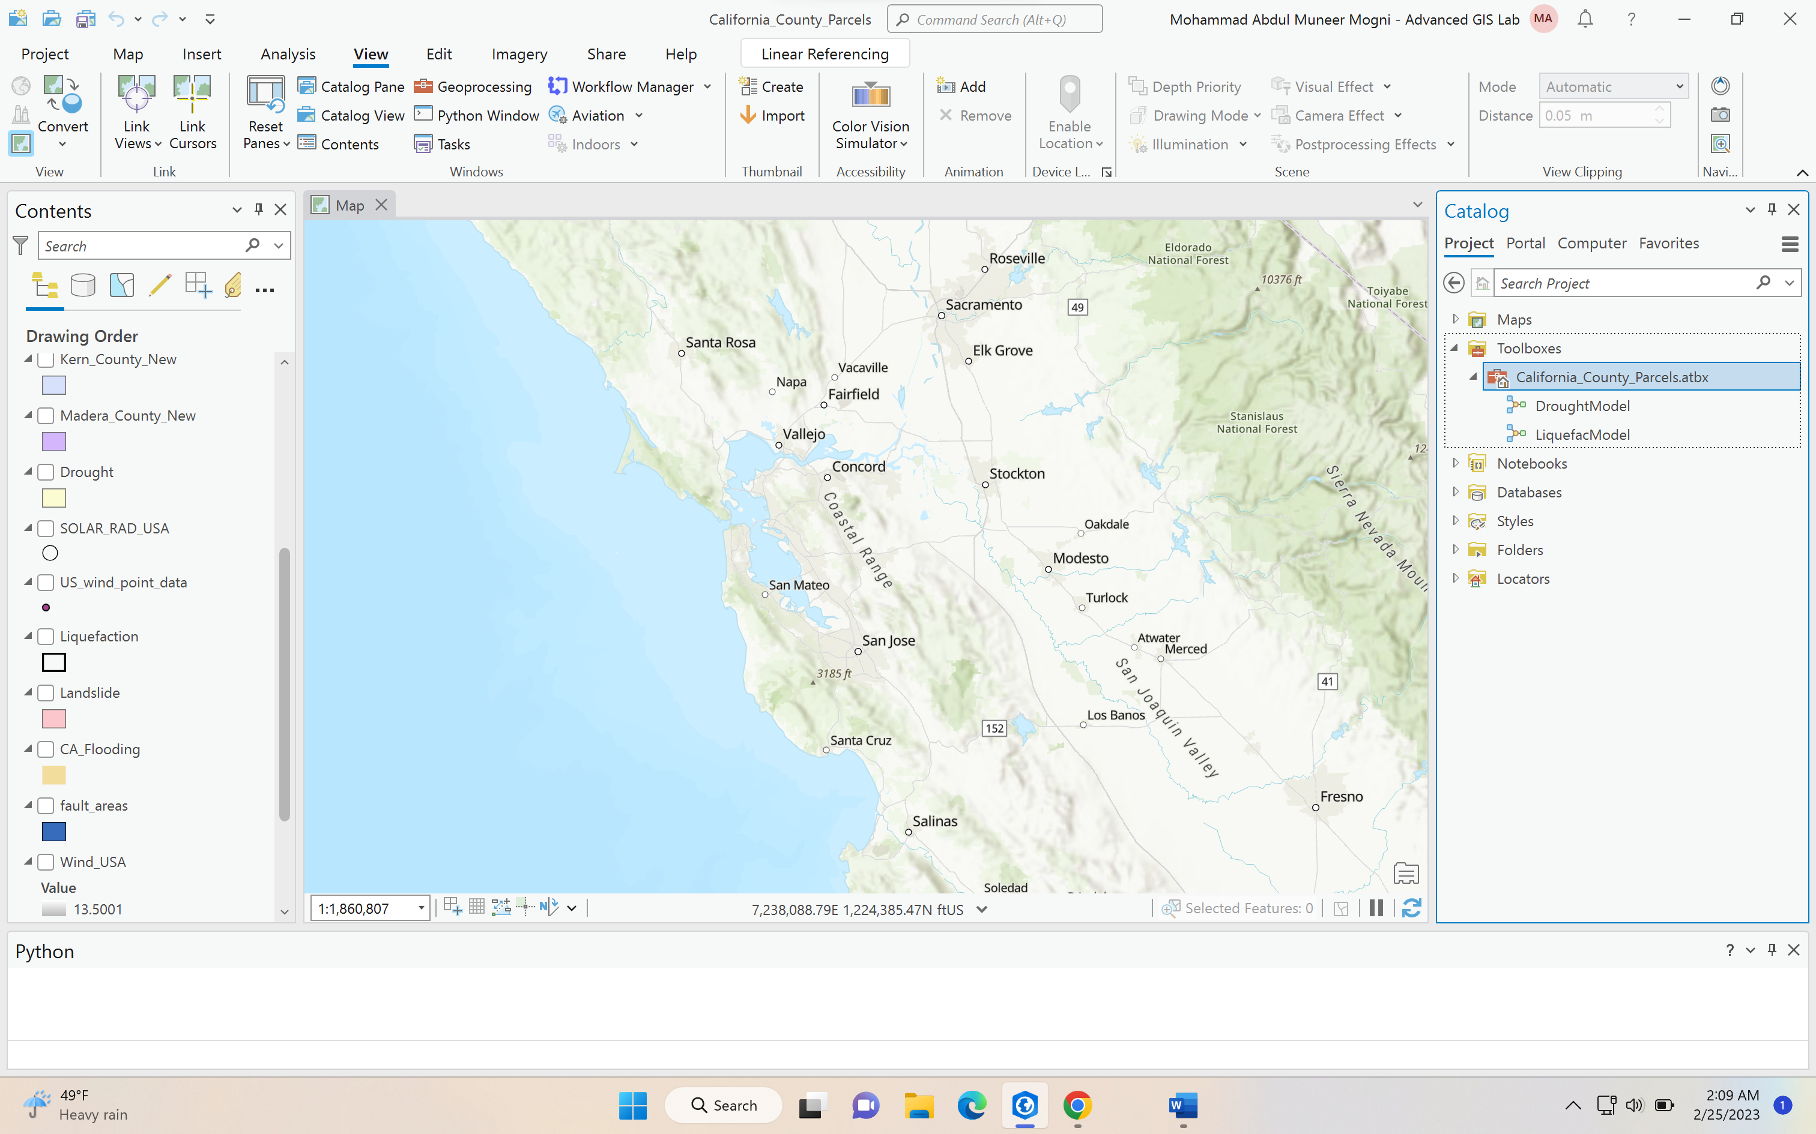

1. Right Click on the Toolboxes and select “**Save Toolbox to Version”**

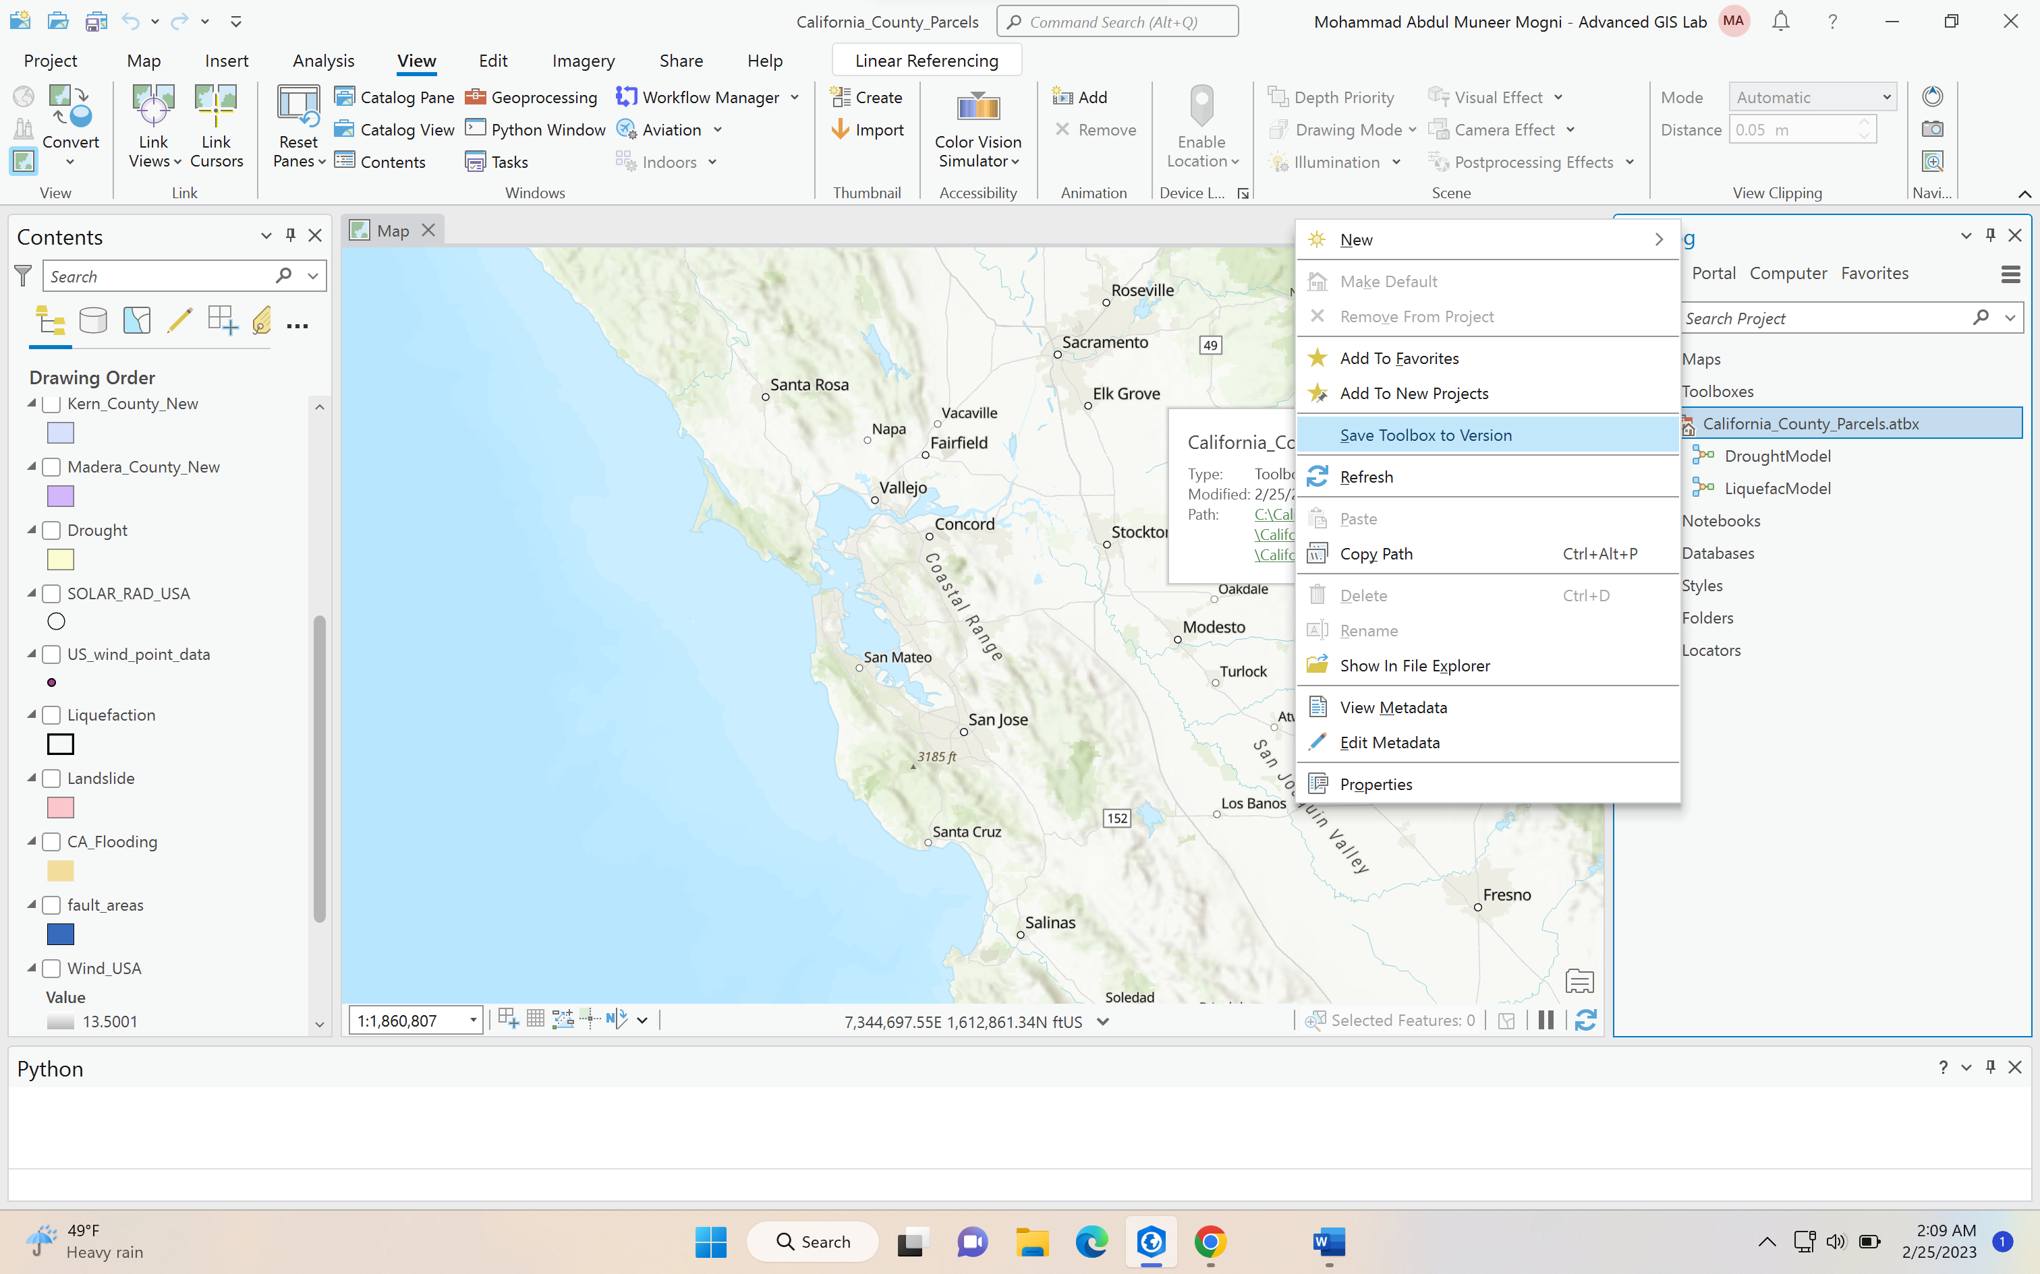

1. Then a window should appear select input as your toolbox

Next target version latest 10.6.0

Next Output select desktop and rename as Model toolbox

Click OK

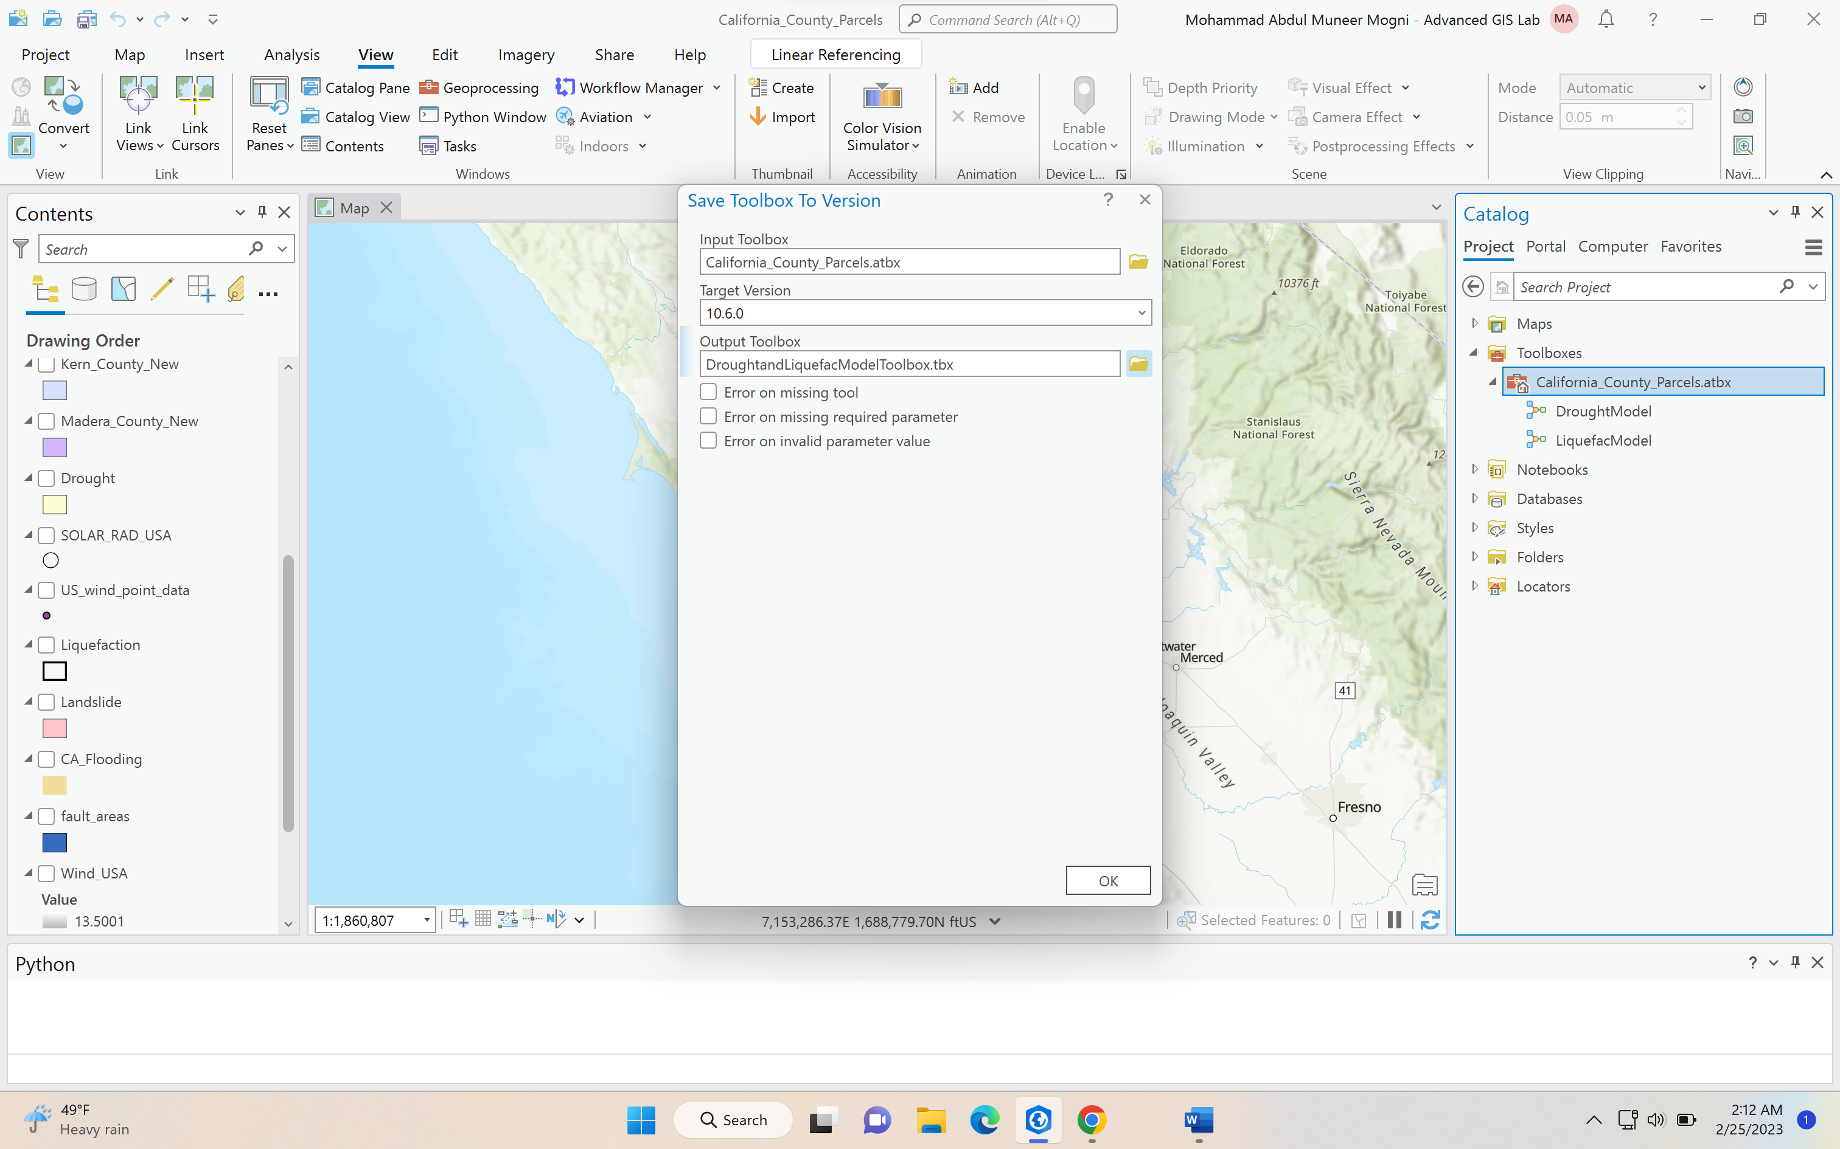

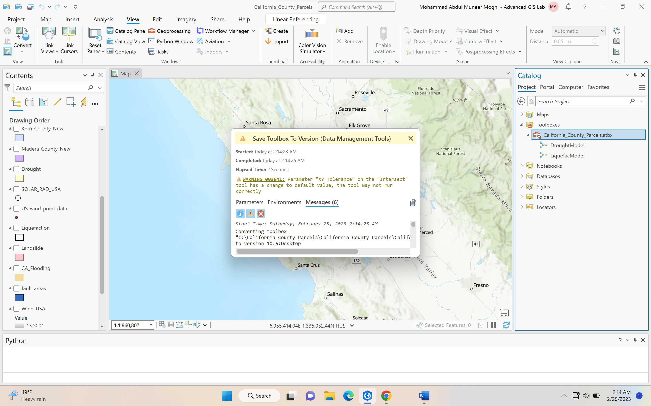

1. On desktop it should you the toolbox

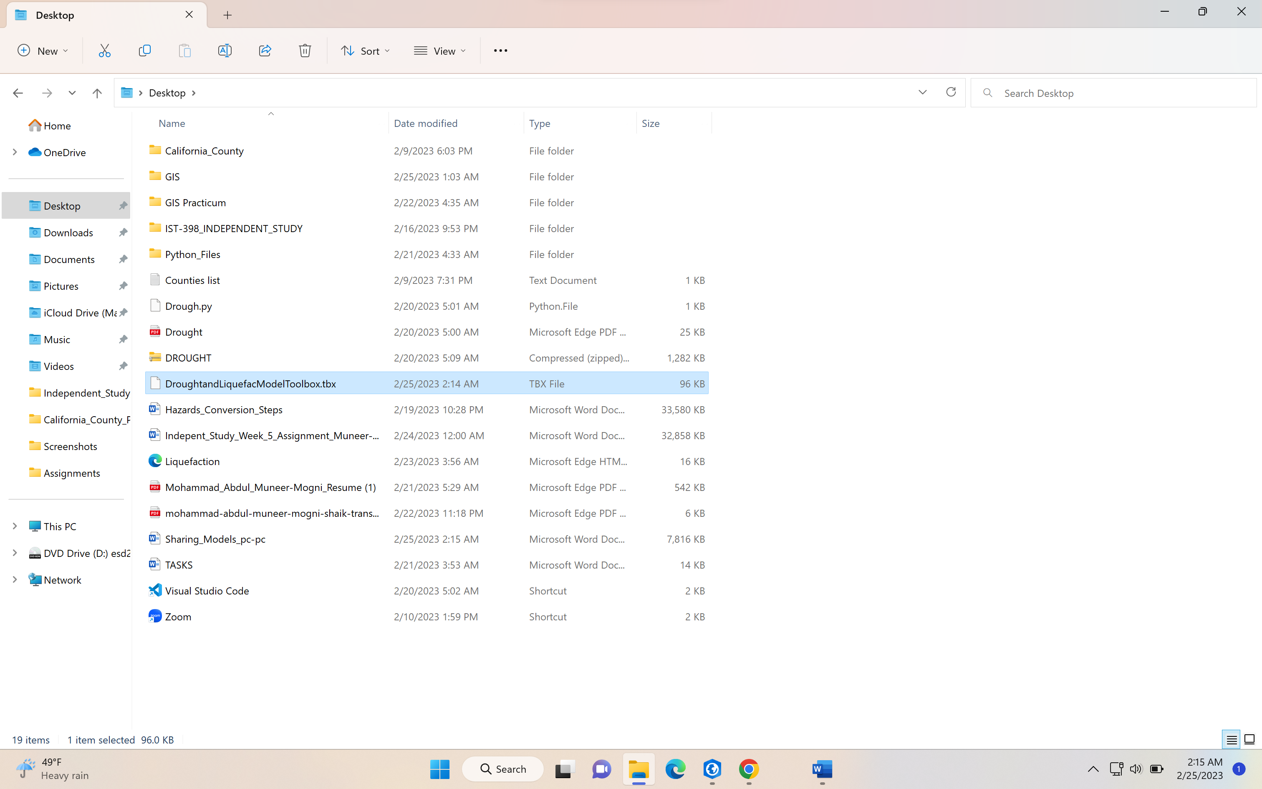

**IMPORTING TOOLBOX IN ARCGIS PRO:**

1. **Go to contents pane and right click on folder to add folder connections**

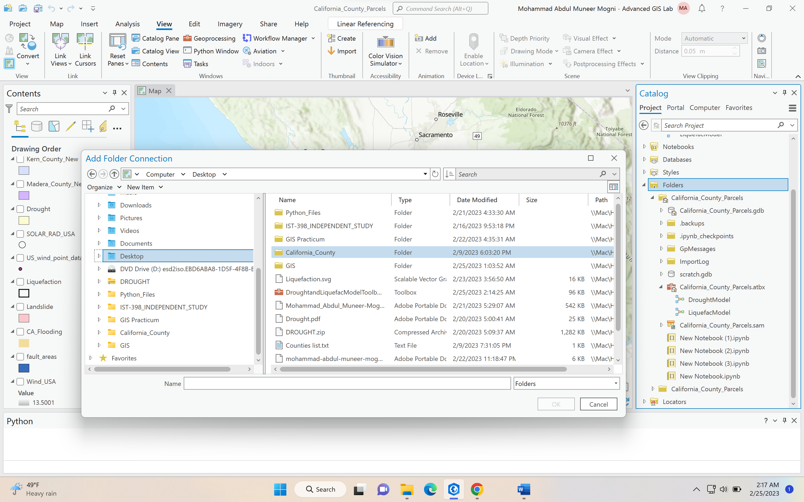

1. **Locate the file toolbox where you have exported or downloaded the file remember to put the toolbox file in a new folder in order to access the toolbox.**

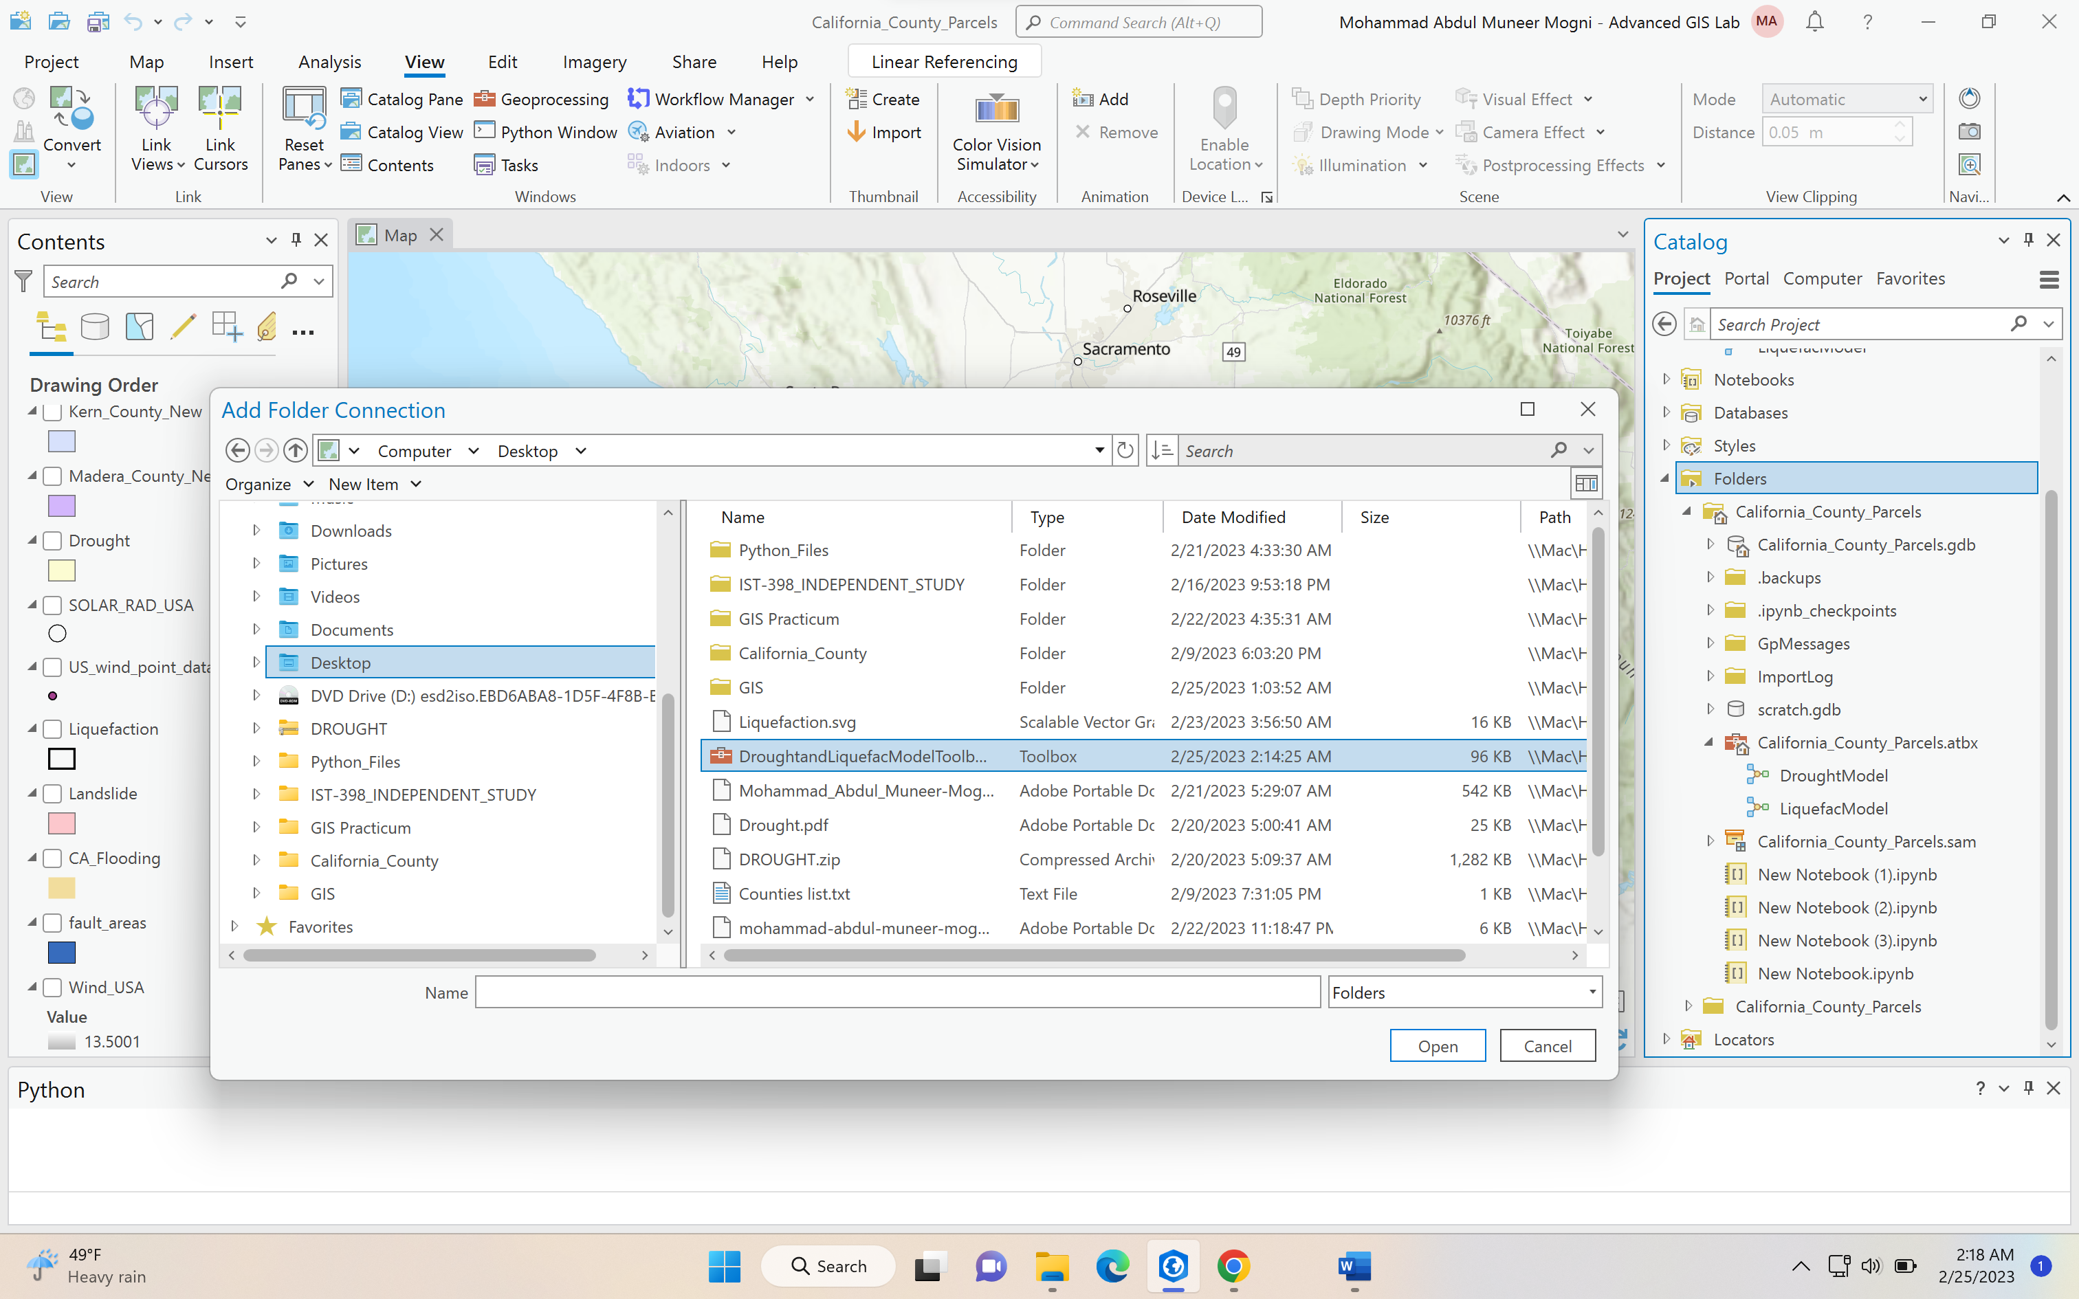

1. **Select the folder where the downloaded toolbox file is: in my case I have created a new file called GIS and pasted my toolbox file inside it**

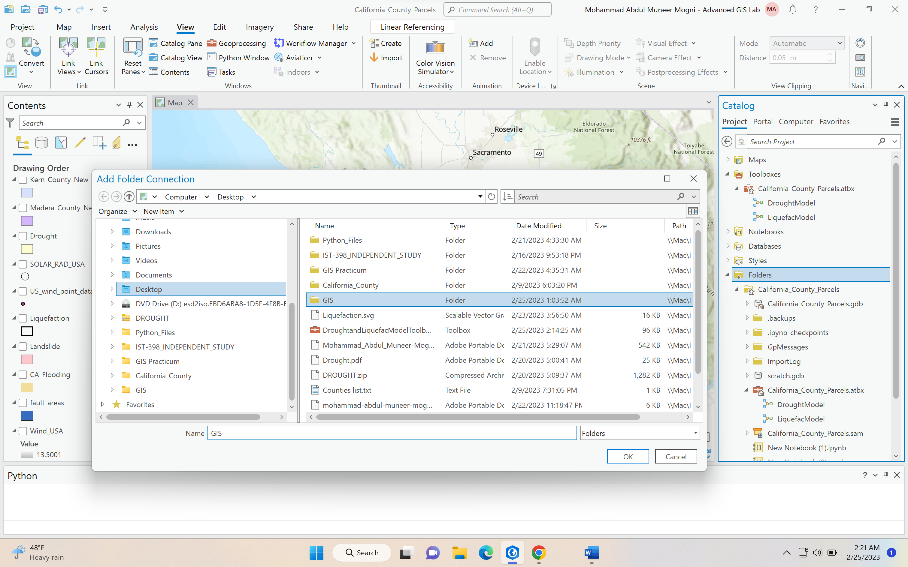

1. **Once the folder is added you can open the folder and see your toolbox**

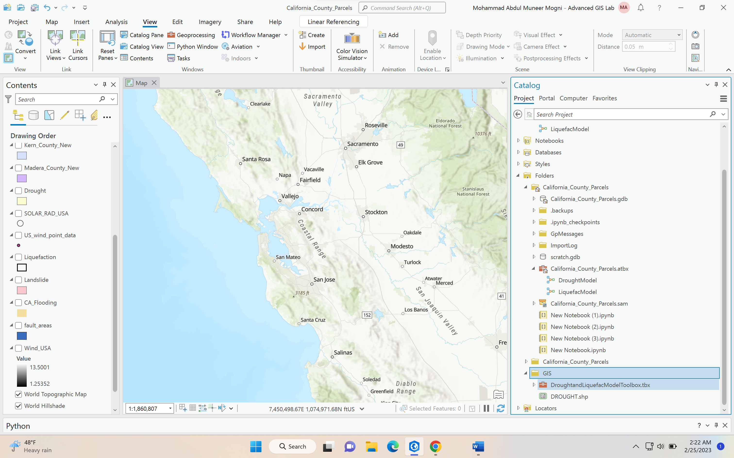

1. **Next open the toolbox to see the models: It will take few seconds to open the toolbox**

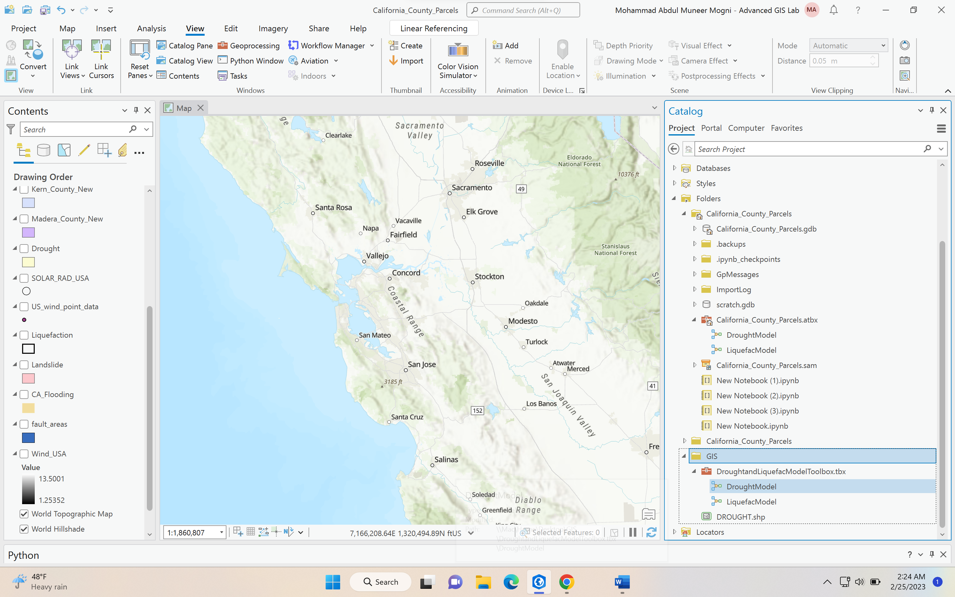

1. **In the last step right click on each model builder and click on edit to see the model builder**

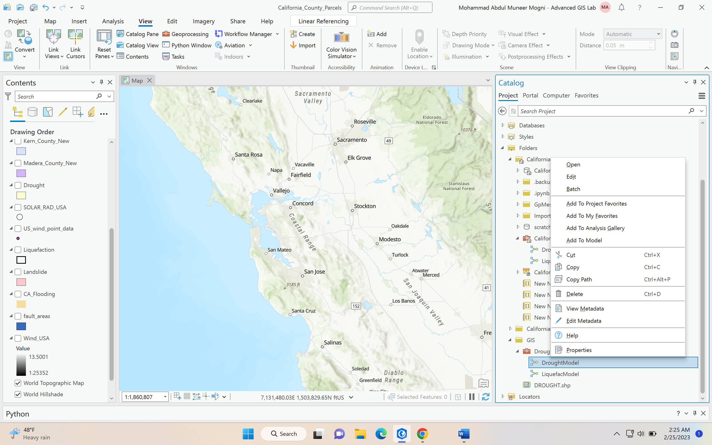

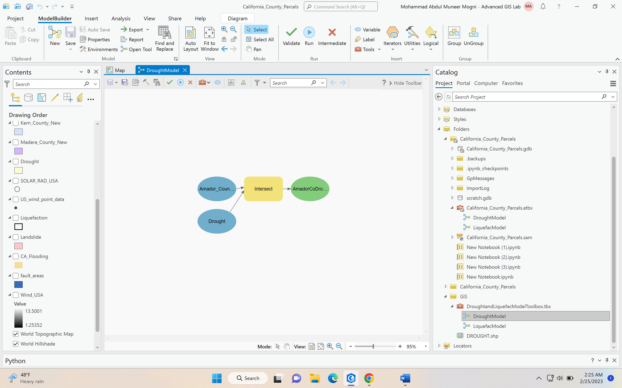

**From here on you can access the model builder directly.**